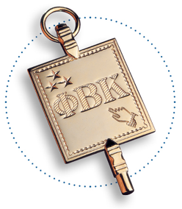

Association Membership Form
New York

Contact Information

Full Name Mr./Ms./Mrs./Miss/Dr. _______________________________________________________

Street_________________________________City/State/ZIP________________________________

Personal Phone Number______________________ Work Phone Number _________________________

Email___________________________________________________________________________

Year Initiated_________School______________________Major/Degree________________________

Name at Initiation (e.g., maiden name) ____________________ ΦBK ID number, if known______________

Employer _______________________________________Job Title___________________________

Does your employer match donations? Yes No

Please Select your Membership Level
Note: Your dues and donations are fully tax deductible

___ Recent Graduate Membership $FREE
___ Annual Dues $30
___ Life Membership Dues $250

Association Preferences

I am interested in assisting the Association with (please check all that apply):
___Programming
___Scholarship
___Finance
___Newsletter
___Membership
___Chapter Association Relationships
___Other:________________________________________________________________________

You can submit this information and payment online at: [ONLINE FORM]

Prefer paper? Please make your check payable to Phi Beta Kappa Association of New York and return this form with your check to:

Phi Beta Kappa Association of New York
P.O. Box 77-1067
Woodside, NY 11377-1067

If you have any questions, please contact:

info@pbkny.org
www.pbkny.org

